Alz-Timerz EMS

Employee Management System

Request for Proposal

Created By; Janelle Salisbury



Table of Contents

Objective

Purpose of Alz-Timerz EMS Application

Audience

Target Audience for Alz-Timerz EMS

Personas

James Pizziola (Owner/Jimmy’s Pizza Shack)

Jenny Black (Employee/Jimmy’s Pizza Shack)

Chantelle Mitchell (Owner/Doggy Day Spaw)

Gary Snell (Employee/Doggy Day Spaw)

Application Overview (Wireframe Presentations)

Overview

Main UI Wireframe

Contact Entry Wireframe

Schedules Wireframe

Shift Requests Wireframe

Map Wireframe

Application Flow Chart

Application Timeline

Overview

Milestone 1 (Week 2)

Milestone 2 (Week 3)

Finished Product (Week 4)

Developer Information

Thank You

Objective

ALz-Timerz is designed for business owners on the go. Its main purpose is to allow easy access to employee records, and scheduling, to help ensure their business runs smoothly. Access is also provided for the employees of each business that is signed up for Alz-Timerz, allowing them to access their co-workers contact information (should they need a replacement for a shift) and also their own personal schedules, ensuring they do not forget when they have to be in for a shift.

When you, the business owner, have completed set up of your business profile within the application, you then will have access to several tabbed resources, such as a list of your employees contact information, a calendar of their schedules for the month, shift changes/requests and a map to locate your competition.

As a client using Alz-Timerz, your employees will also gain access to the application just by you signing up! Each employee must sign in to your account using a name and password, however they will only have access to their co-workers contact information, their own personal schedules and the shift requests tab. Google maps will be provided as well, as a tool for retrieving delivery address locations.

Audience

Who’s Alz-Timerz for?



Grocers…

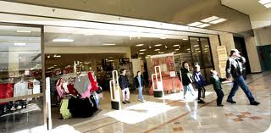

Department Store Managers…

 Restaurateurs…

and all of your employees too…

Persona 1: The Busy Restaurateur

James Pizziola (Owner Jimmy’s Pizza Shack)

Age: 26

Education: College Graduate (Restaurant Management)

Tech Experience: Intermediate

Tech Usage: Daily

Platform: iPhone (Personal) Android (Business)

No of Employees: 50+ (3 locations)



“Being able to keep track of my employees schedules would be a huge plus for me and my business. I am often out of the building for several hours at a time, and if I need to reach an employee if they are a no show, I often have to call the shop and interrupt daily operations for someone to find me a contact number”

James is an incredibly busy restaurant owner, who runs 3 local pizza joints. Being the sole owner, James is often out of each shop for several hours, whether its for business transactions such as banking or covering at another shop because an employee forgot their shift.

Using Alz-Timerz would allow James the freedom of accessing his employees contact information while out of the shop, in case of a no show without forcing him to stop what he is doing, and also forcing his employees to stop what they are doing.

James would also be granted easy access to employee schedules and requests for shift changes or trades right from home without being interrupted, which is extremely beneficial if James is doing bookwork (which can be extremely time consuming and nerve wracking).

Persona 2: Head Server



Jenny Black (Head Server/Jimmy’s Pizza Shack)

Age:19

Education: College Student (Marketing Major)

Tech Experience: Self-Proclaimed Expert

Tech Usage: Excessive User

Platform: Android (Galaxy S3)

“I sometimes forget what time I have to be in for a shift, especially if it is a 4:30 instead of a 4. That half hour time difference throws me off. It would also be nice to be reminded simply by getting a notification or type of buzzer, and Alz-Timerz offers that. College students are busy, it’s easy to forget”

After spending her days on campus soaking up all that knowledge, Jenny sometimes simply forgets she has to be in for the evening dinner shift. Instead of her co-workers (or even James having to come and cover her shift), she cacn simply pull out her phone and check her schedule!

Alz-Timerz sends notifications as well as alarm reminders (if the user should choose) reminding Jenny of her work shift. Alz-Timerz works for Jenny (and you the owner) to ensure her she will almost never be late again.

“One time I had an emergency and needed a cover, but didn’t have anyone’s contact info, so I had to call the Shack and interrupt a busy lunch to get a phone number”

Alz-Timerz allows Jenny to access her co-workers contact information so she can be sure to avoid interrupting busy lunches and her hard working co-workers.

Persona 3: Never in the Office Mabel



Chantelle Mitchell (Owner Doggy Day Spaw)

Age: 38

Education: College Graduate (Vet Science)

Tech Experience: Pretty Proficient

Tech Usage: Daily

Platform: Android (Razr Max)

Number of Employees; 4

“I may not have a lot of employees, but being on the go, walking dogs all day, sometimes I need to call one of my employees. Not being in the Spaw, I don’t have access to their contact information. And it’s kind of hard to remember when trying to walk 4 dogs at once”

Chantelle will benefit mostly from the employee contact portion of Alz-Timerz since she is hardly in the “office”, having the information she needs right in her purse or pocket is a wonderful asset.

With only 4 employees, scheduling is tight, leaving virtually no room for call-ins and no-shows. Having the opportunity to access schedules puts Chantelle at ease knowing that 2 people are scheduled each day. Also, being able to view shift changes ensures Chantelle will be able to properly complete pay roll and bookwork seeing as she acts as her own accountant.

“Having such a great application lets my mind be a little more at ease, knowing my employees can access each other so easily is awesome!”

Persona 4: The 2 Job Employee



Gary Snell (Dog Groomer/Doggy Day Spaw)

Age: 37

Education: Associates Degree (Vet Technician)

Tech Experience: Intermediate

Tech Usage: Daily

Platform: Android (Galaxy Note)

“Sometimes reaching Chantelle about shift swaps is a nightmare, and for me being a vet tech as well as working at Doggy Day Spaw, I usually need to swap one shift a week, sometimes 2. Being able to just swap with someone and not worry about reaching Chantelle is great”

Gary, although busy at the spaw working for Chantelle, also works at a very busy animal clinic as a vet tech. While the animal clinic employs many more people than Doggy Day Spaw it is sometimes necessary for Gary to need a switch.

The schedule and shift request portions of Alz-Timerz is going to be a very frequently used part of the app for Gary, and will provide him the luxury of being able to swap a shift right from the clinic as soon as he receives his schedule instead of having to wait until he travels into the Spaw.

Gary is also in a prime position to introduce Alz-Timerz to his co-workers and employers at the animal clinic, in turn drumming up some potential business from a very prospective client.

Application Overview

Login Screen

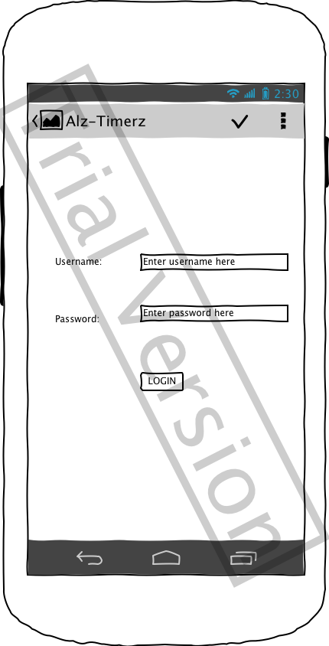

Main User Interface

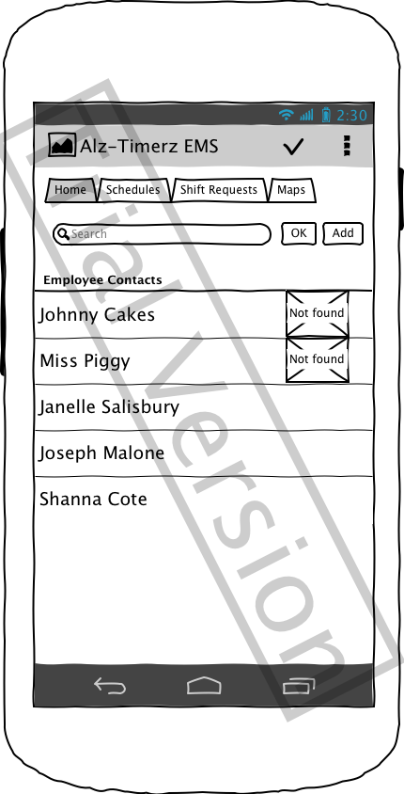

The Main User Interface consists of an action bar located at the top of the application, which showcases the logo branding, title and action bar items such as a refresh for page refresh, a short cut to maps and a settings icon.

There are 4 main tabs. The Home screen, which lists out your employees names and an image and also features a search area and an add button.

Clicking on the add button will bring you to a new screen with a form to add your employees contact information.

Clicking on an employees name will bring you to a detail view, which contains all of their contact information.

Contact Entry

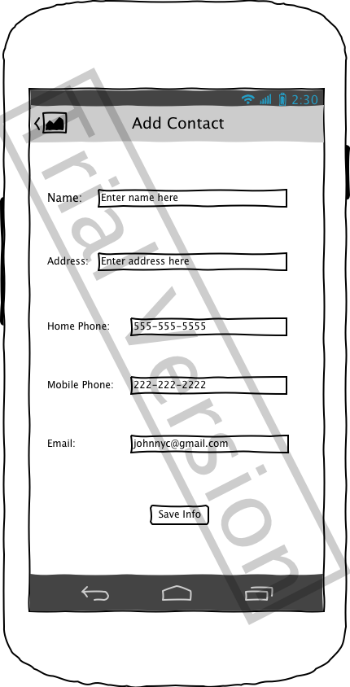

Upon clicking the add button on the Main UI, you will be brough to this screen, which contains a general form for adding your employees contact information to save to the main list-view (home screen)

Schedules

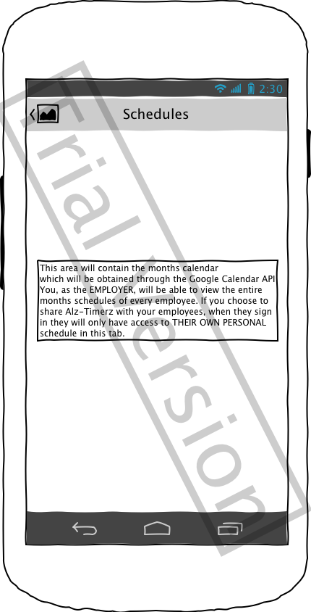

The schedules tab will contain a calendar view, which will be provided by Google Calendars API. In this view, you will be to view a complete monthly calendar of all your employees’ schedules.

Shift Requests

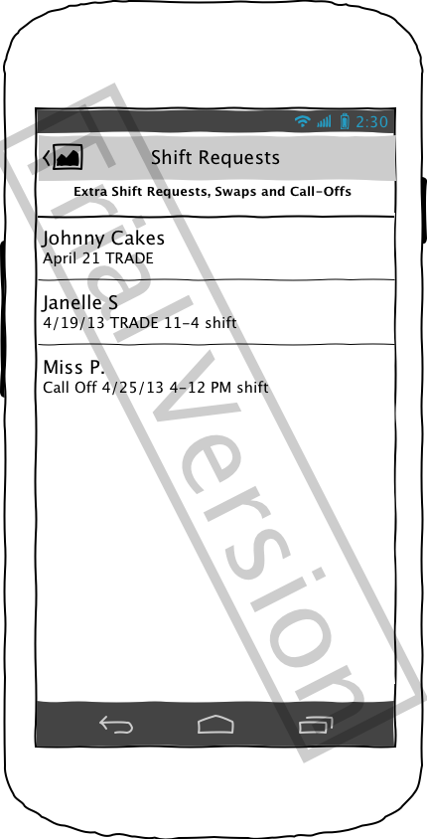

This tab provides user access to any shift changes, shift swap requests or call offs that any employee has requested.

The employees will also have access to the request tab in their employee version, to add their requests for approval.

Shift Request Form

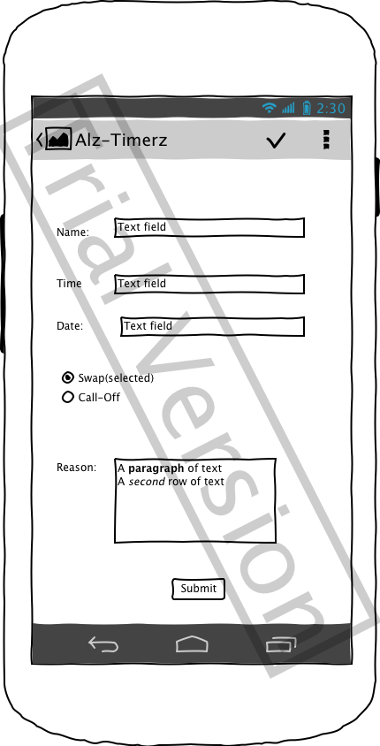

The Request Form for the Employee Version, which allows Employees to enter their request and post it to the system for other employees to view as well as you, the owner

Google Maps

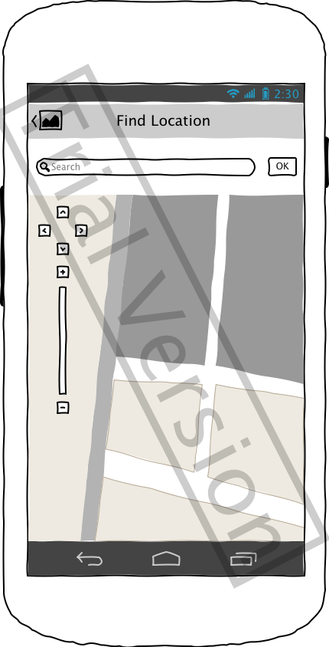

The Maps tab of Alz-Timerz will provide you, the business owner access to the Google Maps API to search and locate local competition and delivery locations should you need.

The API will also be offered in the employee version, for your delivery personnel to search and locate delivery addresses.

Application Timeline

Overview

The following timeline is a formal guide provided to you, the client, outlining the 3 (weekly) stages of project development.

Each weekly document will provide and outline that will be implemented and completed for the milestone deadline of Thursday by 12 Midnight.

Throughout the development of this application a milestone document will be provided for development weeks 2 and 3, and with week 4 will come the final document, your completed Android application.

Milestone 1: Week 2 (30 hours)

Deadline: Thursday April 18, 2013 12 Midnight

Tasks to be completed:

* Create project files using Eclipse IDE
* Create a User Interface (projects main layout) for both the Employer and Employee versions of Alz-Timerz

\*Build a tabbed interface with four (4)

tabs (Home, Schedules, Shift Requests,

and Maps)

\*Code functionality for the basics of

each tab (ListView, WebView, General

Form)

\*Create a user log-in and code function-

ality for name and password entry

(using Google AccountManager)

* Create an action bar (shortcuts bar located

at the top right of application) and code

for a settings icon, refresh icon and an

overflow (item may be present, functionality

will be added at later time)

* Finish at least Home screen with the add

function, so the user can add an employee

to their log and the Request tab to perform

same functionality (may need extra work

next week to ensure proper functionality).

Milestone 2: Week 3 (40 hours)

Deadline: Thursday April 25, 2013 12 Midnight

Tasks to be completed:

* Add custom graphics and images
* Begin implementation of Google Calendar API for

the schedule tab of the application (Full implementation will be completed week 4)

* Add camera functionality for image capture
* Create alarm/notifications
* Ensure proper screens are in place and functional
* Complete action bar icons and functionality, adding

a shortcut for the camera.

* Complete the Google Maps API tab
* Choose an appropriate color scheme and custom graphics.
* Begin looking at the Parse API to store and share information between versions and screens (Full implementation will not be complete until week 4)

Finished Product (15 hours)

Deadline: Thursday May 2, 2013 12 Midnight

Tasks to be completed:

* Continue with coding functionality using Parse API
* Continue with Storage functionality
* Complete all coding functionality for Alz-

Timerz

* Present the client with a completed, polished

Alz-Timerz Android Application.

Upon completion of Alz-Timerz EMS the user will be able to create a user account and have access to employee information, as well as distribute the employee version to their employees.

Monetization

Weekly Development Time:

Week 1: 20 hours

Week 2: 30 hours

Week 3: 40 hours

Week 4: 15 hours

Total Billable Hours: 105 hrs

Hourly Rate: $100

Total Cost: $10,500

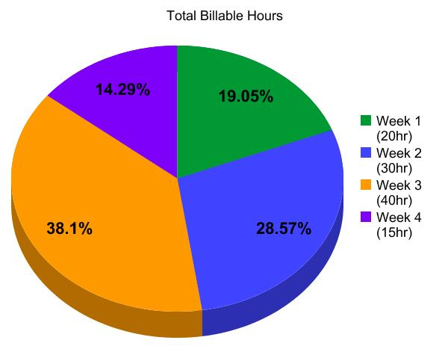

Week 1- Wireframe creation and Request for Propsal Documentation

Week 2- Milestone 1

Week 3- Milestone 3

Week 4- Completed Product

Return on Investment:

Alz-Timerz will consist of a paid version, in which the business owner purchases the Alz-Timerz EMS for the purchase price of $2.99. They will receive the basic Alz-Timerz application, allowing them, and only them to access all of the features available.

For another $1.99, they will have the option to purchase the Employee version of Alz-Timerz, which allows their employees to access their own personal schedules and all the other features as well, and provide it to their employees. Thus ensuring that the application is truly working for them, and also their employees.

The real benefit and your best buy are to purchase both versions of the application.

Developer Info

Janelle Salisbury is currently a 4th year Mobile Development Major at Full Sail University, located in Orlando Florida. Janelle is completing her degree program as an online student.

In her free time, Janelle enjoys watching hockey, riding motorcycles, camping, spending time at home and playing with her dog. She is also an accomplished chef.

Upon graduation, Janelle would like to continue on with her education obtaining a Masters Degree in Mobile Marketing. She hopes to one day get a job developing mobile software and applications and also marketing them to the public.



Janelle currently lives in Potsdam New York, located in Upstate New York. She shares a 150 year old Victorian home with her partner Michael and their dog Josie and also Michaels son Carson when he comes to visit.

\*\*All photos used were used with permission of the person in the image\*\*

\*\*Photos taken from web images were checked for public use allowance\*\*